**CURRENT TRENDS**

* Complications in Paediatric RA (ADARPEF Study in 1996, 2010)
* Overall RA complication rate in children is low at 0.09-0.12%.
* Complications are more frequent in children<6 months
* CNB has higher (6X) complications than PNB
* Trends in Paediatric RA
* There is a move from CNB to PNB (40%→66% in ADARPEF’s study)
* Caudals still account for most (80%) of CNB
* PNB offers the advantage of providing a target-controlled area of localized anaesthesia / analgesia, reducing the amount of LA used, thus systemic absorption is smaller. It is most useful in cases where CNB is contraindicated Eg. Truncal PNB may substitute CNB for laparotomy
* Technique evolution
* Timeline
  + - 1962- nerve stimulator
    - 1994- ultrasound
    - 2003- ultrasound in paediatric RA
* Ultrasound vs nerve stimulator
  + - Shorter block performance time
    - Higher success rate
    - Longer block duration
    - Less volume of LA
    - Visibility of neuraxial structures esp in infants<3mth old
    - Useful in paralysed patients or those with neuropathy

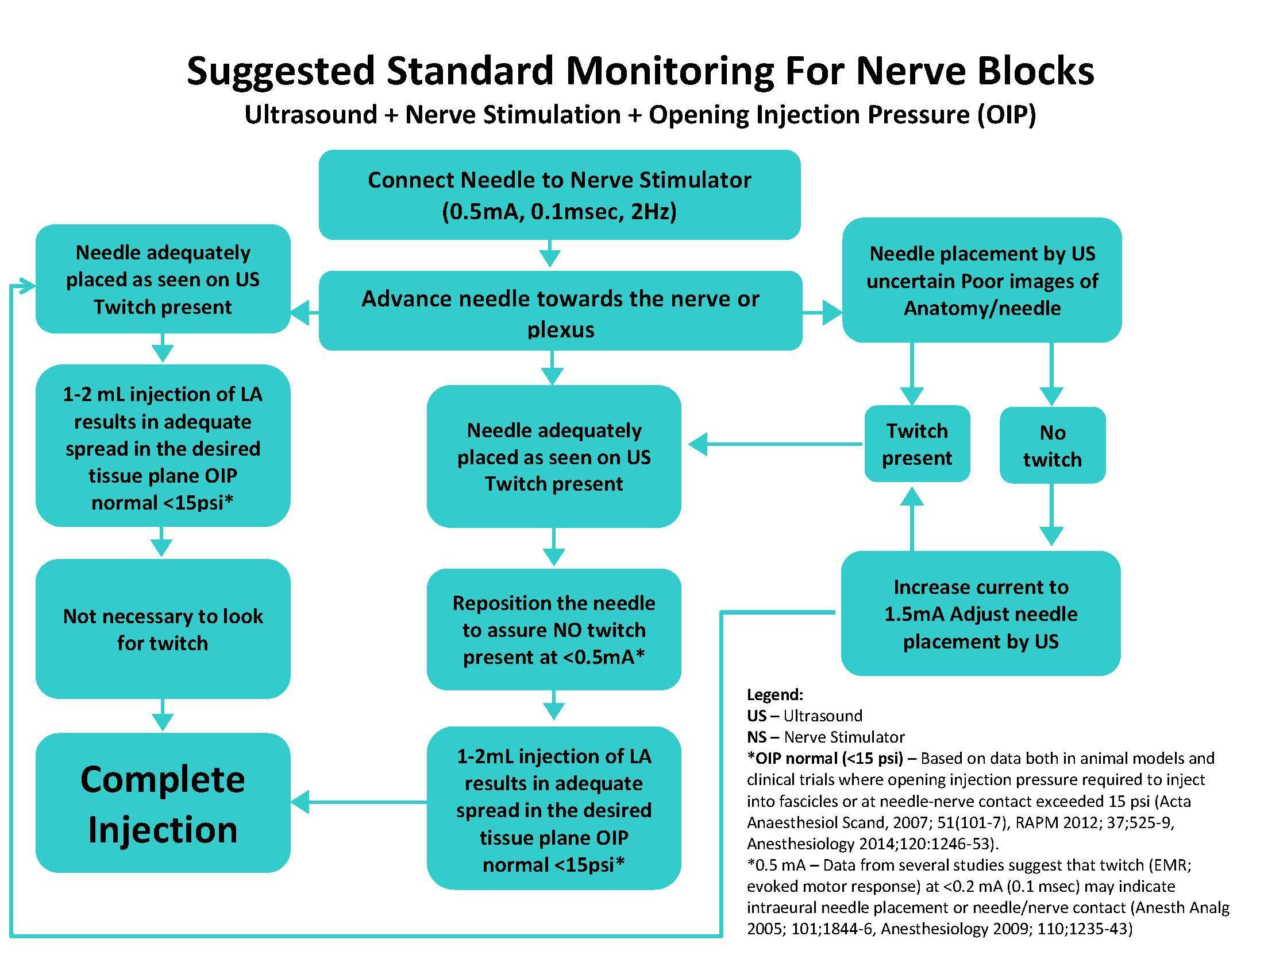

*References:*

1. *Eccofey C, Lacroix F, Giaufre´ E et al. Epidemiology and morbidity of regional anaesthesia in children: a follow-up one-year prospective survey of the French-Language Society of Paediatric Anaesthesiologists (ADARPEF). Pediatr Anesth 2010; 20: 1061–1069.*
2. *Polaner DM et al. Pediatric Regional Anesthesia Network (PRAN): a multi-institutional study of the use and incidence of complications of pediatric regional anesthesia. Anesth Analg. 2012 Dec;115(6):1353-64*
3. *Rubin K, Sullivan D, Sadhasivam S. Are peripheral and neuraxial blocks with ultrasound guidance more effective and safe in children? Pediatr Anesth 2009; 19: 92–96*
4. *Marhofer, P., Ivani, G., Suresh, S., Melman, E., Zaragoza, G., Bosenberg, A. (2012), Everyday regional anesthesia in children. Pediatric Anesthesia, 22: 995–1001*
5. *The ASRA Evidence Based Medicine Assessment of the UGRA and pain medicine. Reg.Anesth and Pain Medicine 2010; 35;S1-9*
6. *NYSORA textbook. Hadzic’s Peripheral nerve blocks and anatomy for ultrasound-guided regional Anaesthesia T*
7. *Ecoffey C, Bosenberg A, Lonnqvist PA, Suresh S, Delbos A, Ivani G. Practice advisory on the prevention and management of complications of pediatric regional anesthesia. J Clin Anesth. 2022 Aug;79:110725. doi: 10.1016/j.jclinane.2022.110725. Epub 2022 Mar 18. PMID: 35313269.*